**Customer Churn Prediction using MySQL**

**1)Question:** How many customers are there in the customer churn data?

**Ans:-** select count(CustomerID) from customer_churn_data;

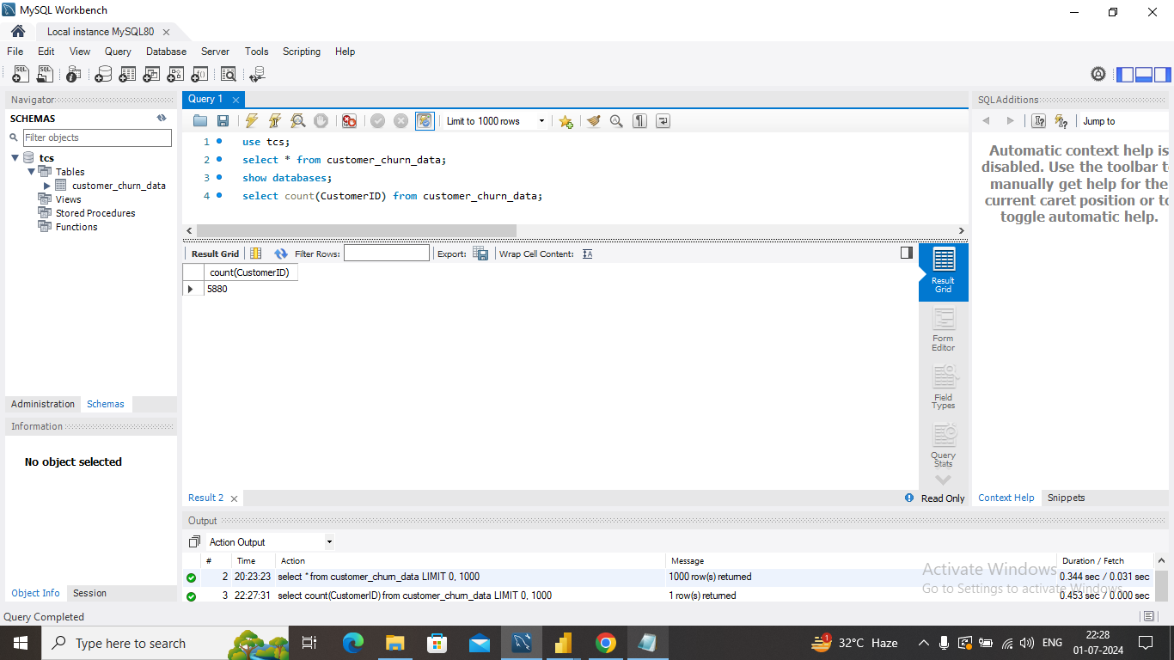

**2)Question:** How many senior citizens with phone service are in each gender category?

Top of Form

Bottom of Form

select count(Gender) as Gender_Count, Gender from customer_churn_data where PhoneService="Yes" and SeniorCitizen="Yes" group by Gender;

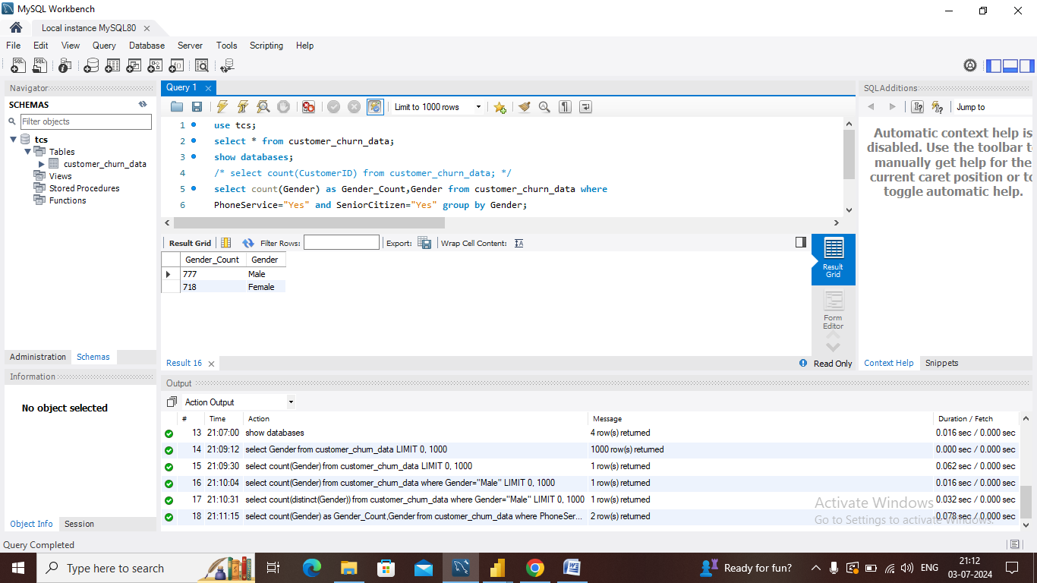

**3)Question:** What are the total monthly charges by contract type?

Top of Form

Bottom of Form

select distinct(Contract), round(sum(MonthlyCharges),2) as Monthly_Charges from customer_churn_data group by Contract;

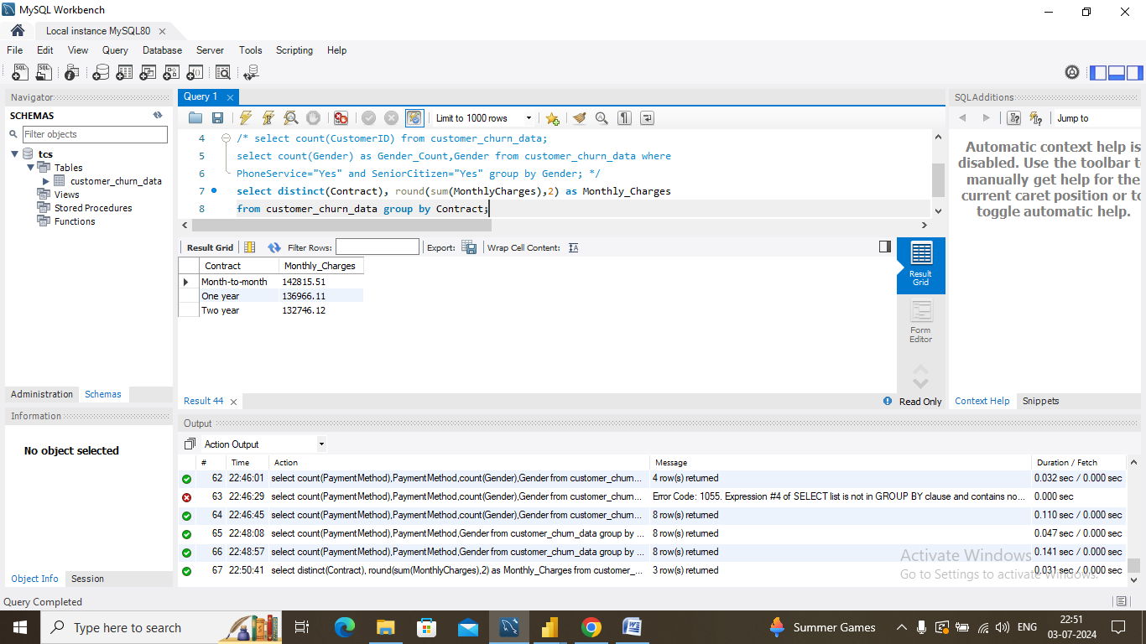

**4)Question:** How many customers use each payment method, categorized by gender?

select count(PaymentMethod) as PayMethod_Count,PaymentMethod,Gender from customer_churn_data group by PaymentMethod,Gender order by PaymentMethod;

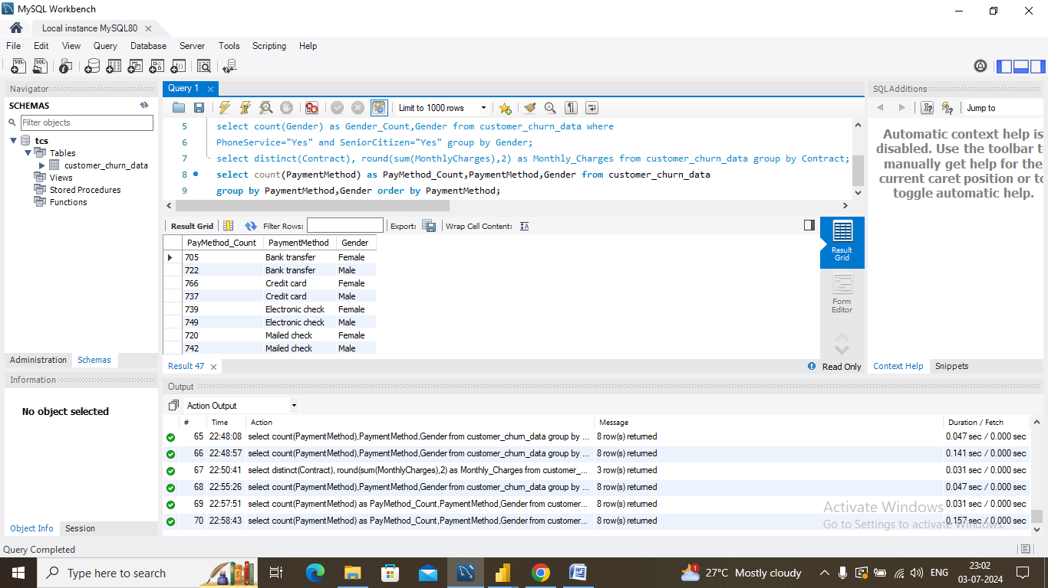

**5)Question:** How do total monthly and total charges vary across payment methods and contract types?

Top of Form

Bottom of Form

select distinct(PaymentMethod),round(sum(MonthlyCharges),2) as Mntly_Charges, round(sum(TotalCharges),2) as Ttl_Charges,Contract from customer_churn_data group by PaymentMethod,Contract order by PaymentMethod;

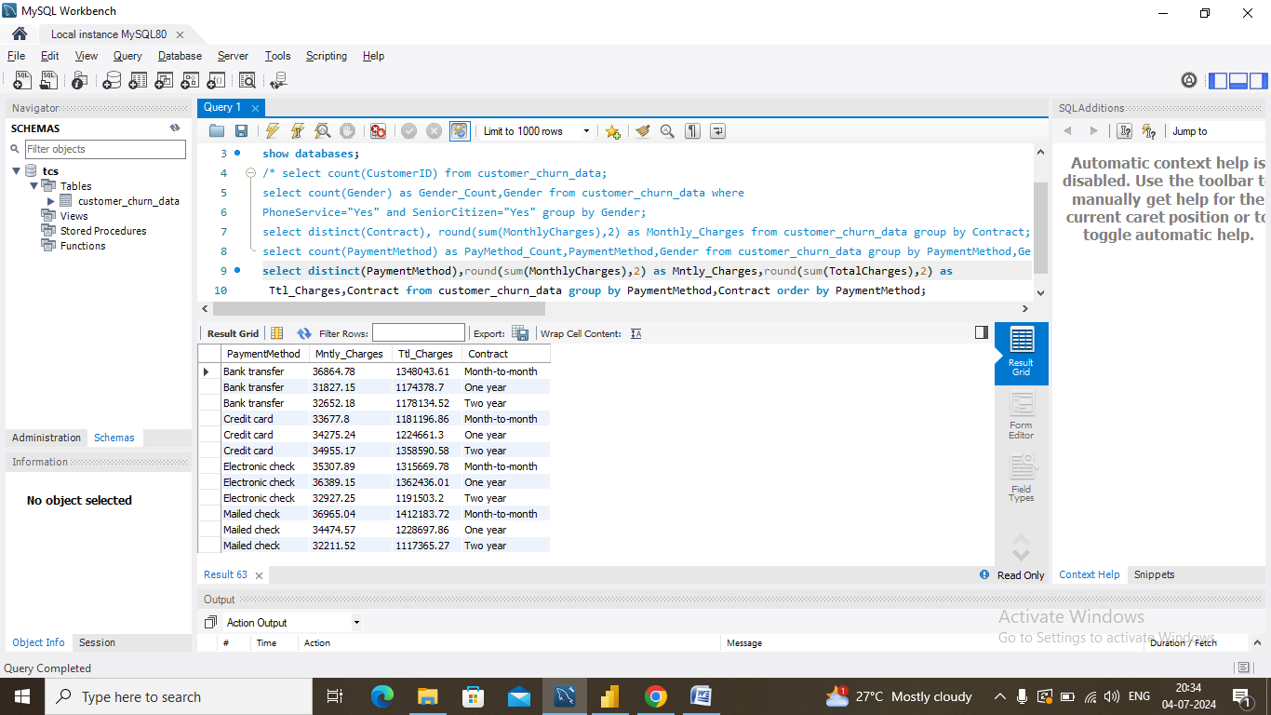

**6)Question:** How many customers fall into each combination of gender, Internet service type, online backup usage, and device protection?

select count(Gender) as Gender_Cnt,Gender,InternetService,OnlineBackup, DeviceProtection from customer_churn_data group by Gender,InternetService,OnlineBackup,DeviceProtection order by Gender;

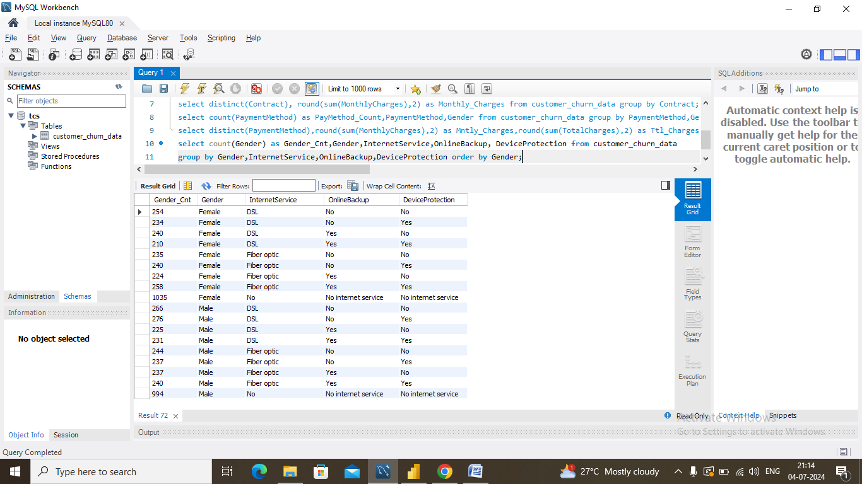

**7)Question:** Which 10 customers, categorized by gender, have the lowest total monthly charges?

select Gender,CustomerID,sum(MonthlyCharges) from customer_churn_data group by

Gender,MonthlyCharges,CustomerID order by sum(MonthlyCharges)asc limit 10;

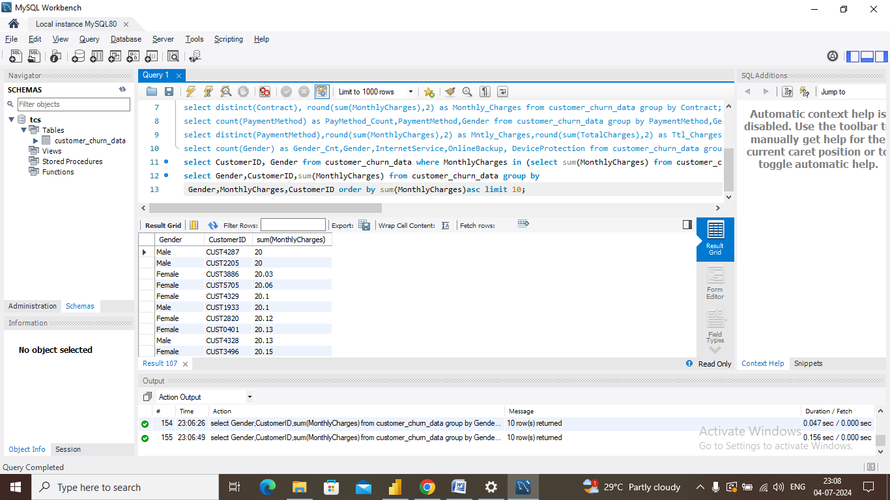

**8)Question:** Which 10 customers, categorized by gender, have the highest total monthly charges?

select Gender,CustomerID,sum(MonthlyCharges) from customer_churn_data group by

Gender,MonthlyCharges,CustomerID order by sum(MonthlyCharges)desc limit 10;

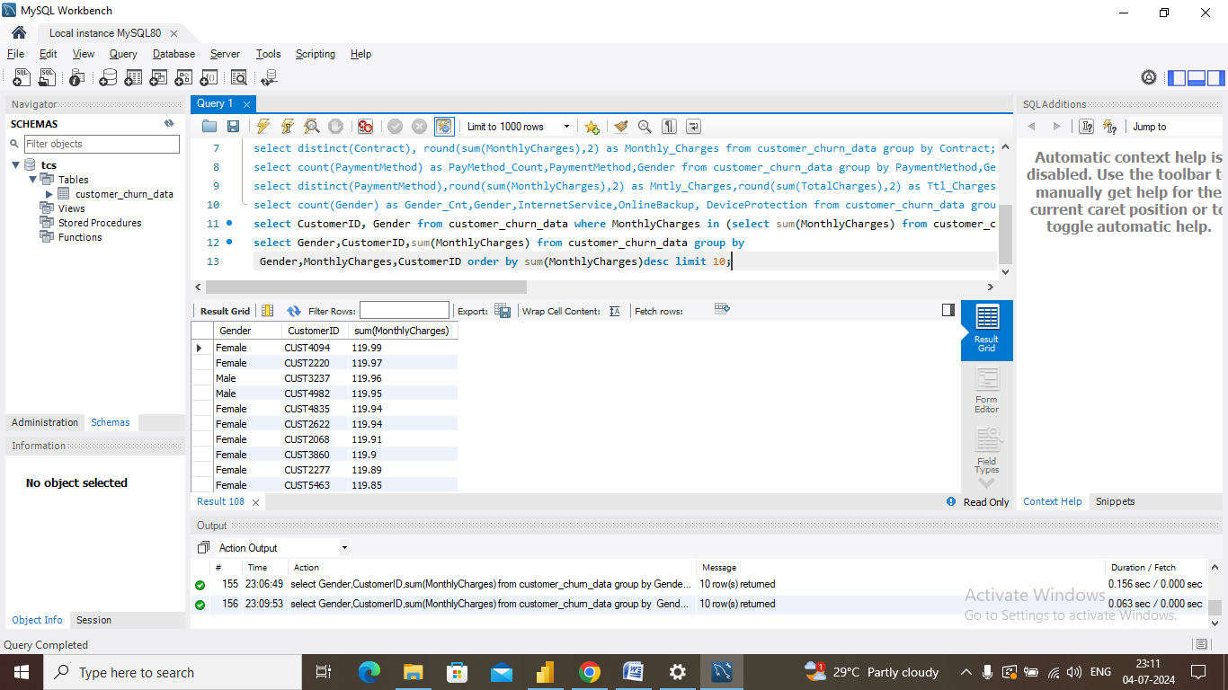

**9)Question:** How many customers are there for each combination of dependents, partner status, and multiple lines?

select count(Dependents) as Dependents_Cnt,Dependents,Partner,MultipleLines from

customer_churn_data group by Dependents,Partner,Multiplelines order by Dependents desc;

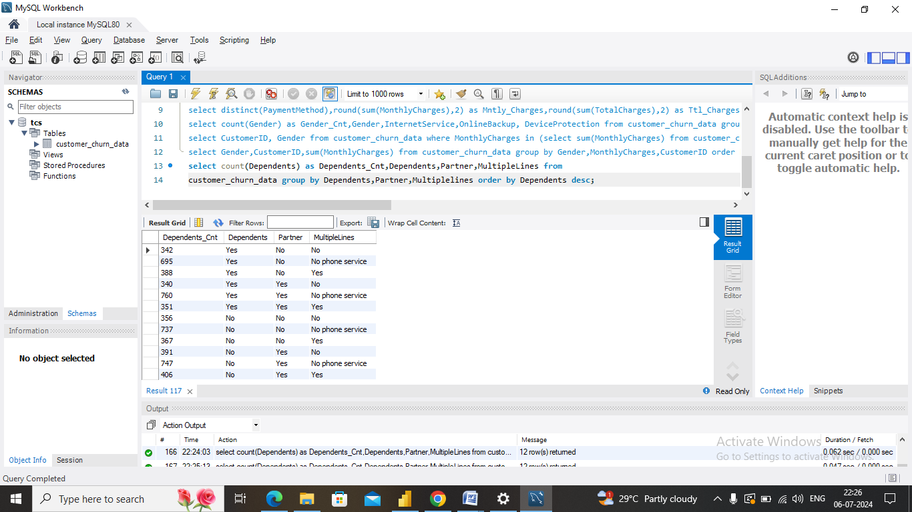

**10)Question:** How does the total tenure in days and years vary for customers based on their online security usage and churn status?

select sum(Tenure) as Ttl_Days,round(sum(Tenure)/365,0) as Ttl_Yrs,OnlineSecurity,Churn

from customer_churn_data group by OnlineSecurity,Churn order by Churn;

